
HRMIS User Guide
Revision History
Version | Author | Date | Remarks
1.0 | Jeswin Chacko P A | 02-Sep-2020 | Created

Table of Contents
1 ADMIN MODULE 3
1.1 EMPLOYEES 3
1.1.1 View Employee 3
1. Add Employee : For add employees 4
1.1.2 Add Employee 4
1.1.3 Edit/View Employee 5
1.2 lookup table 8
1.2.1 Designation 8
1.2.2 Location 10
1.2.3 Client 11

ADMIN MODULE
The administrator can login to the system using the,
URL: http://103.71.171.3:8888/HRMIS/
User name : ICS0220186
Password : Indocosmo123.
On successful login the Admin Main window will be displayed.
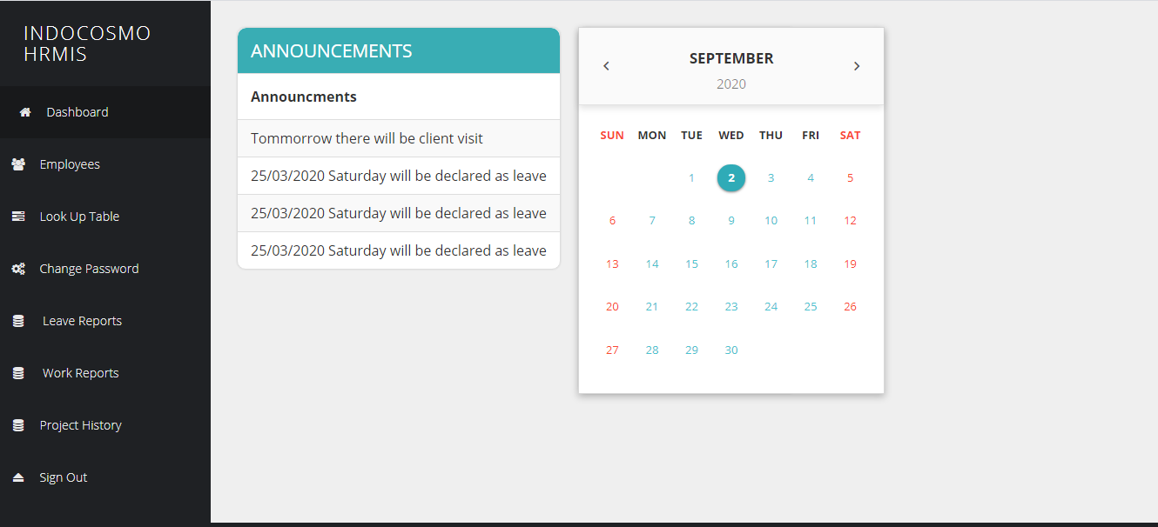
The admin module allow administrator to setup and maintain the employees details,view reports and controll the dropdown values.

EMPLOYEES
Employee Details creation,view,edit and delete will be in this section.

View Employee
Employees will be viewed in this section as a table.
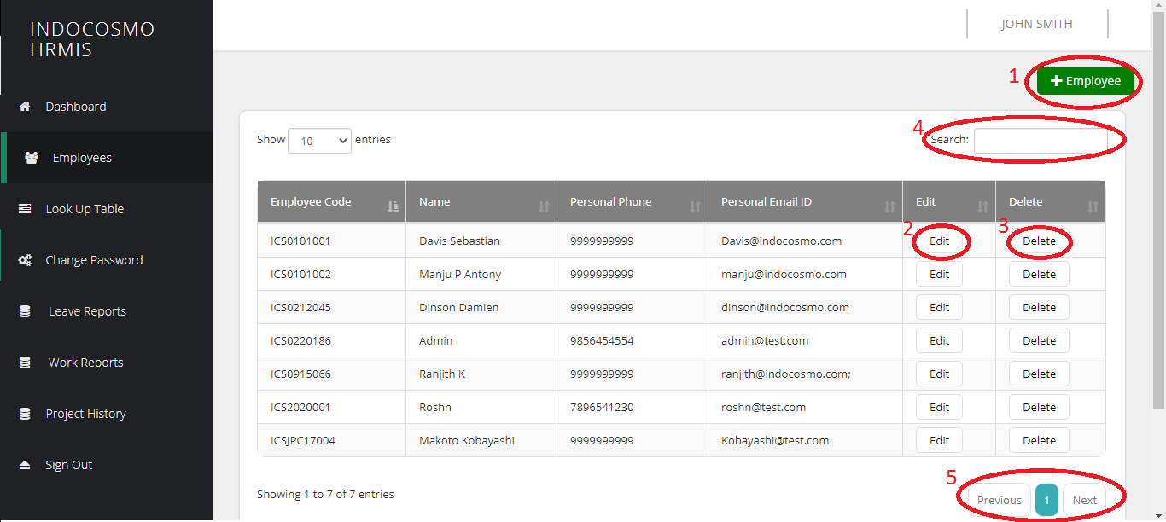

Add Employee : For add employees
- Edit Employee : Edit the corresponding employee details
- Delete Employee : Delete an employee
- Search : Search employee in the table
- Pagination : Next and Previous pages of employees

Add Employee
Employees will be added in this page.

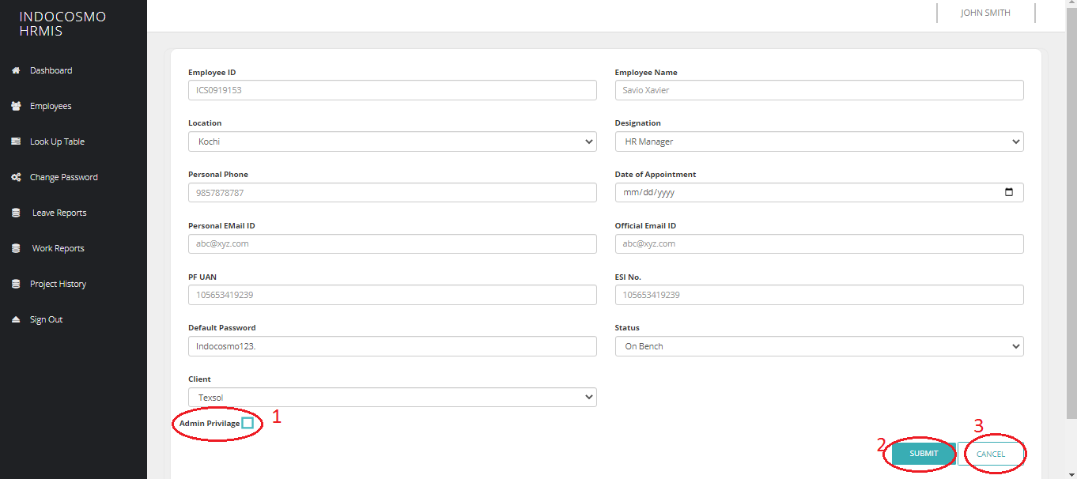
- Admin Privilage : By checking this checkbox corresponding employee will be an administrator of the system
- Submit : By click on the submit button employee details will be saved and redirected to the employee view page(1.1.1).
- Cancel : By click on the cancel button page will be redirected to the employee view page(1.1.1).

Edit/View Employee
Employee details view and edit will be done in this page. This page contains employee project details and approvers other than employee details.
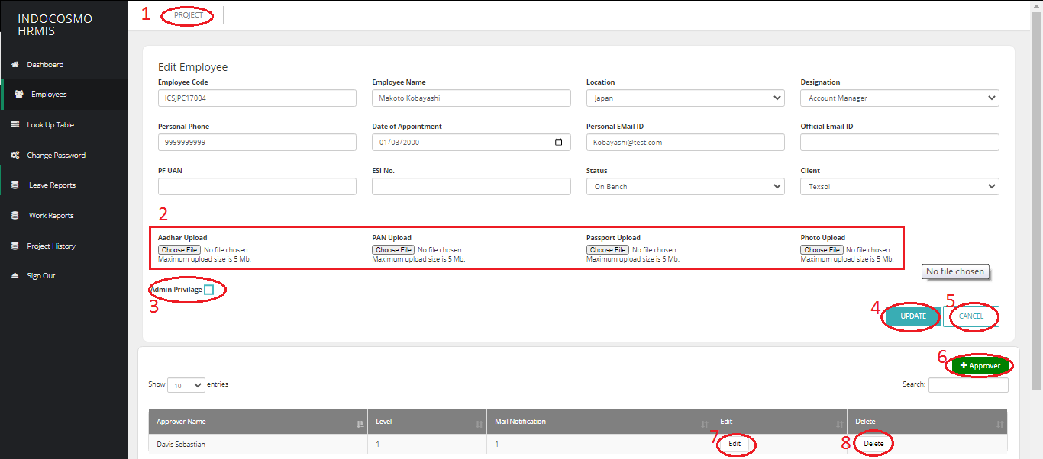
- Project : On click in this link page will be redirected to the employee projects page.
- Documents : Choose files to upload the documents.
- Admin Privilage : admin privilage can be added.
- Update : On click details edited will be updated and redirected to employee view page(1.1.1).
- Cancel : On click, edited details will be disacarded and redirected to employee view page(1.1.1).
- Add Approver : On click, redirected to add approver page and leave approvers for correspondant employee will be added in this page.
- Edit : On click, page will be redirected to edit approver page.
- Delete : Approver of the employee will be deleted.

View Project
Projects for employees will be added,edited and deleted in this section.
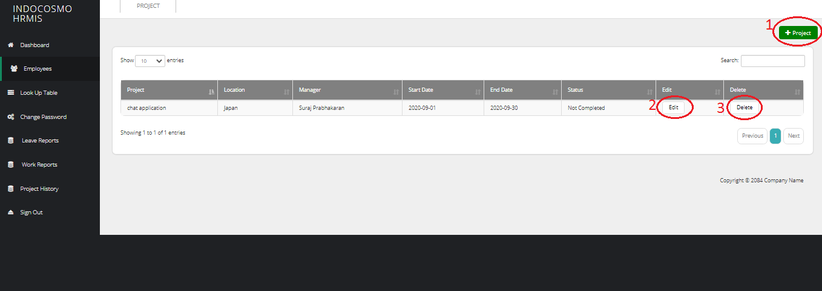
- Add Project : On click, the page will be redirected to create project.
- Edit : On click, the page will be redirected to edit the project.
- Delete : Delete the project.

Add Project
Project will be created in this page
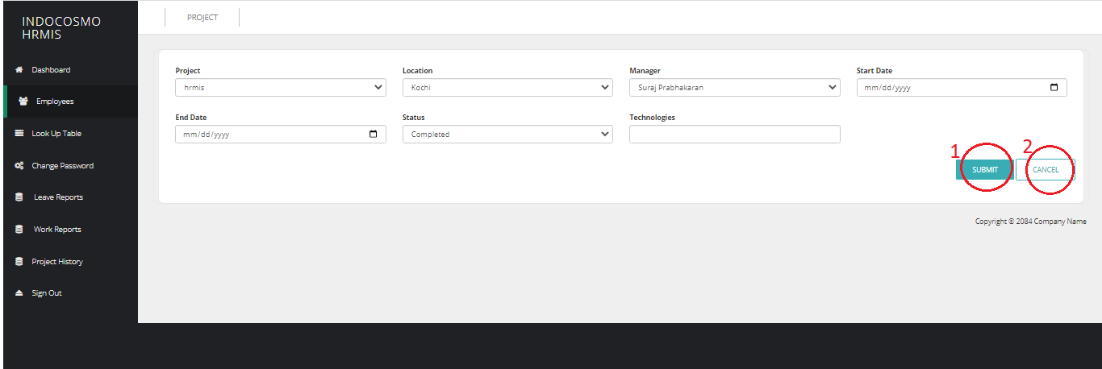
- Submit : Project details for correspond employee will be created and redirected to view project page(1.1.3.1).
- Cancel : Project details entered will be discarded and redirected to view project page(1.1.3.1).

Edit Porject
Project details will be edited in this page.
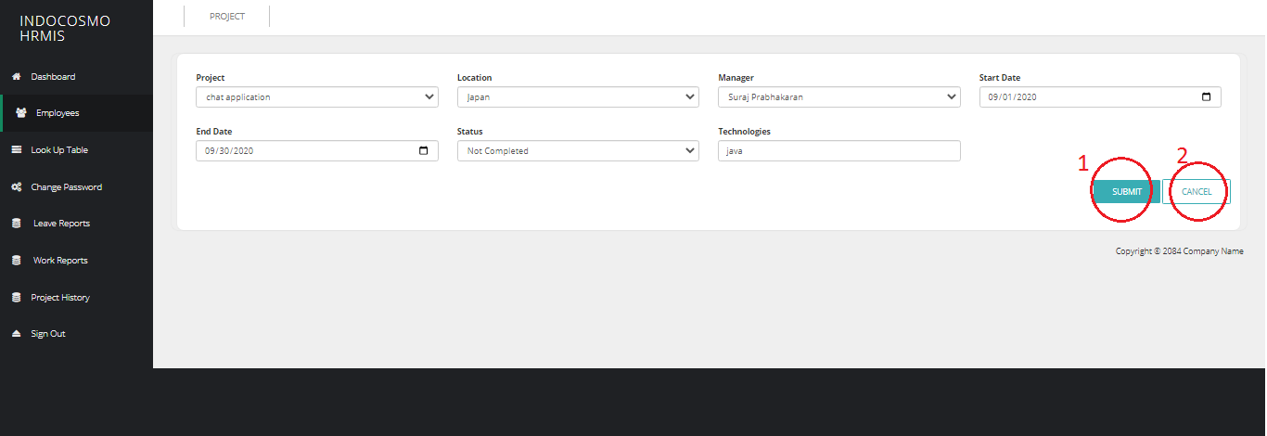
- Submit : On submit, the edited details will be submited and redirected to the project view page(1.1.3.1).
- Cancel : On submit, the edited details will be discarded and redirected to the project view page(1.1.3.1).

Add Approver
Approver for the employee will be created in this page.
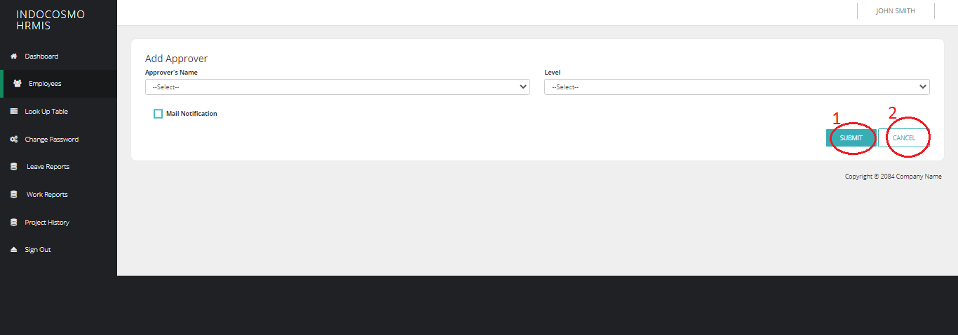
- Submit : On submit, the approver for correspond employee will be created and redirected to the edit employee page(1.1.3).
- Cancel : On click, the entered details will be discarded and redirected to the project view page(1.1.3).

Edit Approver
Approver details will be edited in this page.
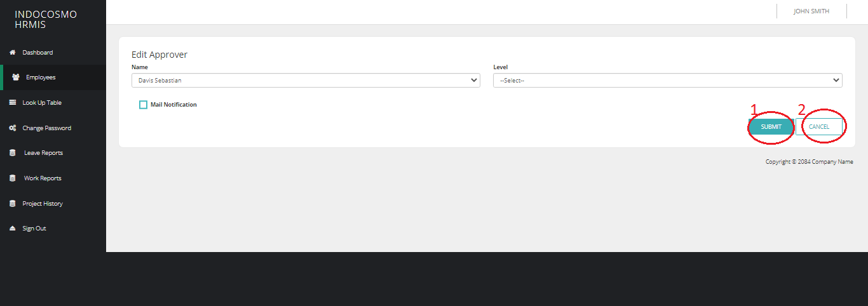
- Submit : On submit, the edited details will be submited and redirected to the edit employee page(1.1.3).
- Cancel : On submit, the edited details will be discarded and redirected to the project view page(1.1.3).

lookup table
This section allows administrator to create,edit,view and delete the options that can be used in different forms or sections.

Designation
Designation page allows administrator to create,edit,view and delete designations for employee forms

View Designation
This page shows the list of designations created
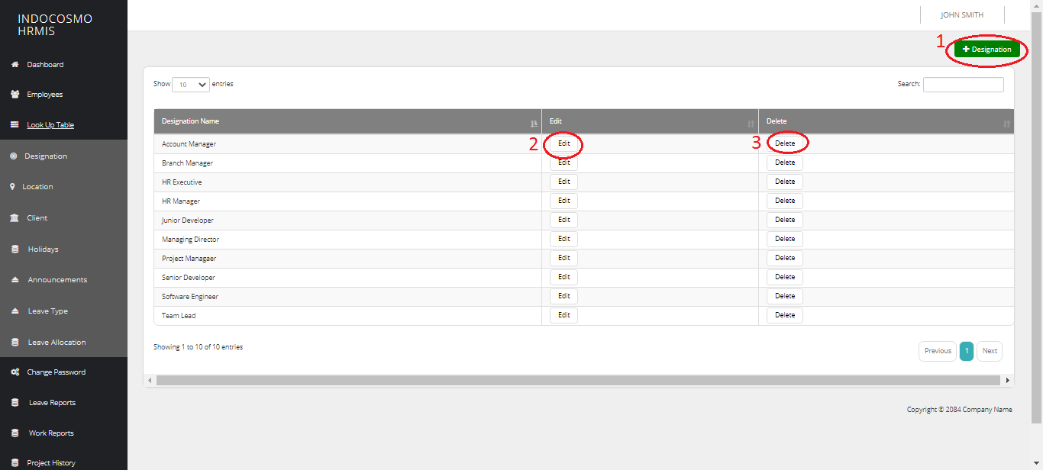
- Add Designation : Page will be redirected to creation page of designation.
- Edit : Page will be redirected to edit page of designation.
- Delete : Designation will be deleted.

Add Designation
Designation will be created in this page.
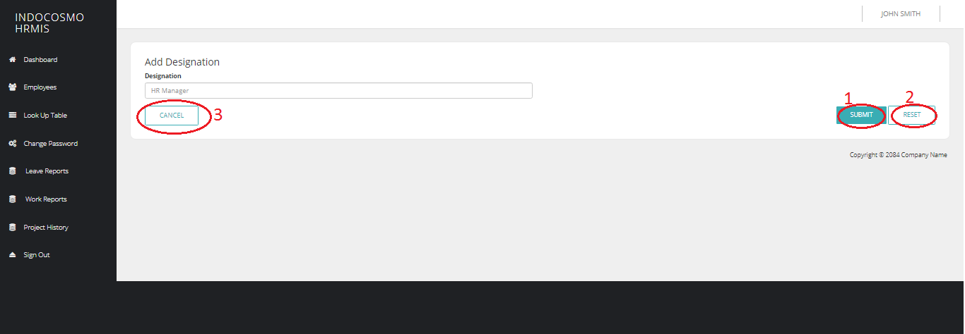
- Submit : On submit, new designation will be created and page will be redirected to view designation page(1.2.1.1).
- Reset : On reset, details entered will be reseted.
- Cancel : On cancel, creation of designation will be discarded and redirecetd to view designation page(1.2.1.1).

Edit Designation
Designation can be edited in this page.
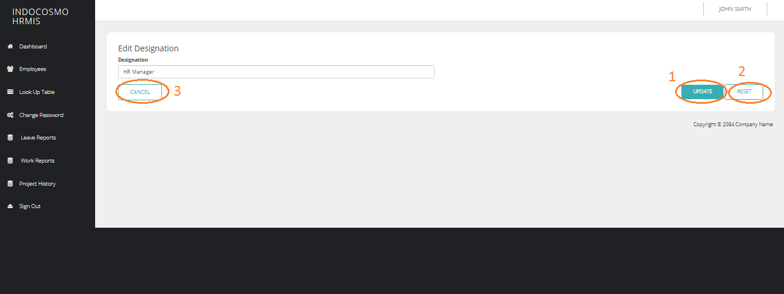
- Submit : On submit, designation will be edited and page will be redirected to view designation page(1.2.1.1).
- Reset : On reset, details entered will be reseted.
- Cancel : On cancel, editing of designation will be discarded and redirecetd to view designation page(1.2.1.1).

Location
Location page allows administrator to create,edit,view and delete locations for employee forms

View Location
This page shows the list of locations created
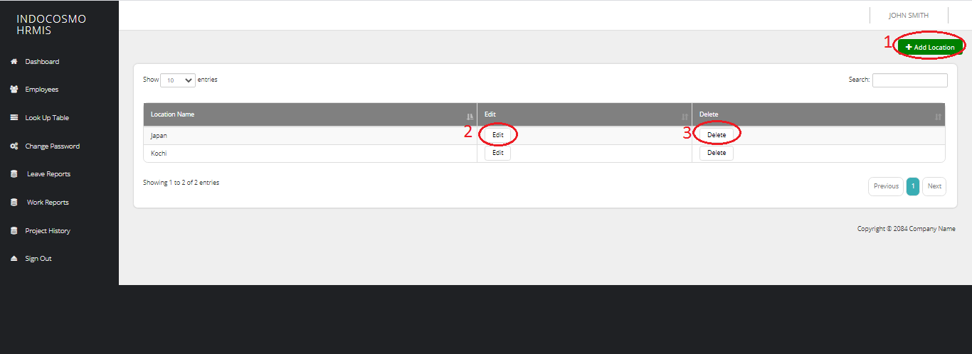
- Add Location : Page will be redirected to creation page of location.
- Edit : Page will be redirected to edit page of location.
- Delete : Location will be deleted.

Add Location
Designation will be created in this page.
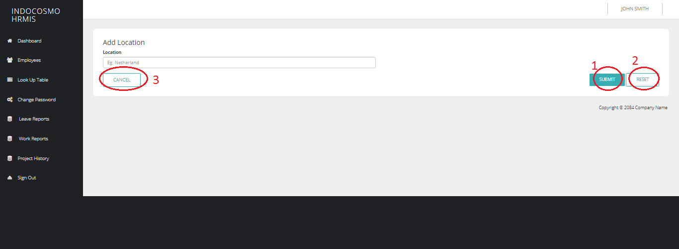
- Submit : On submit, new location will be created and page will be redirected to view designation page(1.2.2.1).
- Reset : On reset, details entered will be reseted.
- Cancel : On cancel, creation of location will be discarded and redirecetd to view designation page(1.2.2.1).

Edit Location
Designation can be edited in this page.
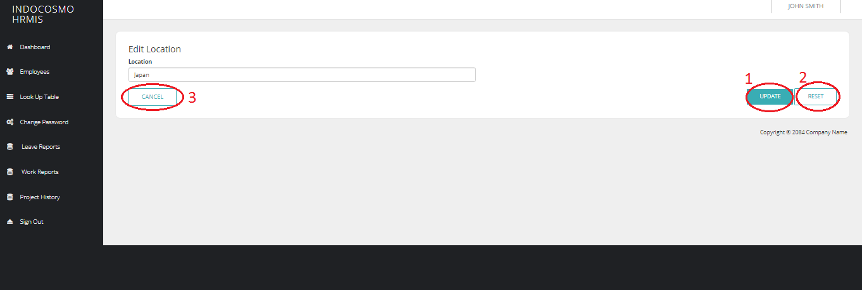
- Submit : On submit, location will be edited and page will be redirected to view designation page(1.2.2.1).
- Reset : On reset, details entered will be reseted.
- Cancel : On cancel, editing of location will be discarded and redirecetd to view designation page(1.2.2.1).

Client
Client page allows administrator to create,edit,view and delete clients,projects,and project manager for employee forms.

View Clients
This page shows list of clients created.
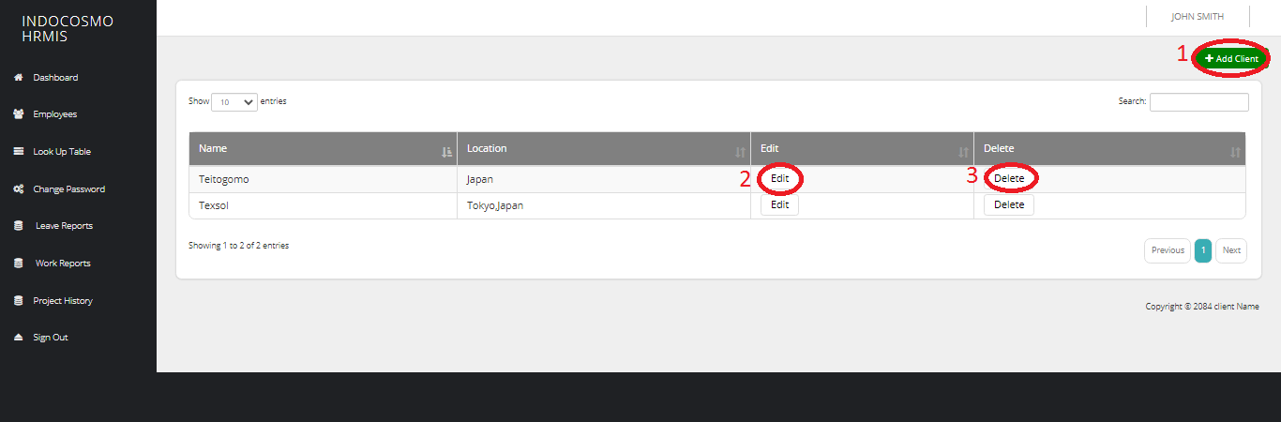
- Add Client : Page will be redirected to creation page of client.
- Edit : Page will be redirected to edit page of client
- Delete : Client will be deleted

Add Client
Client will be created in this page.
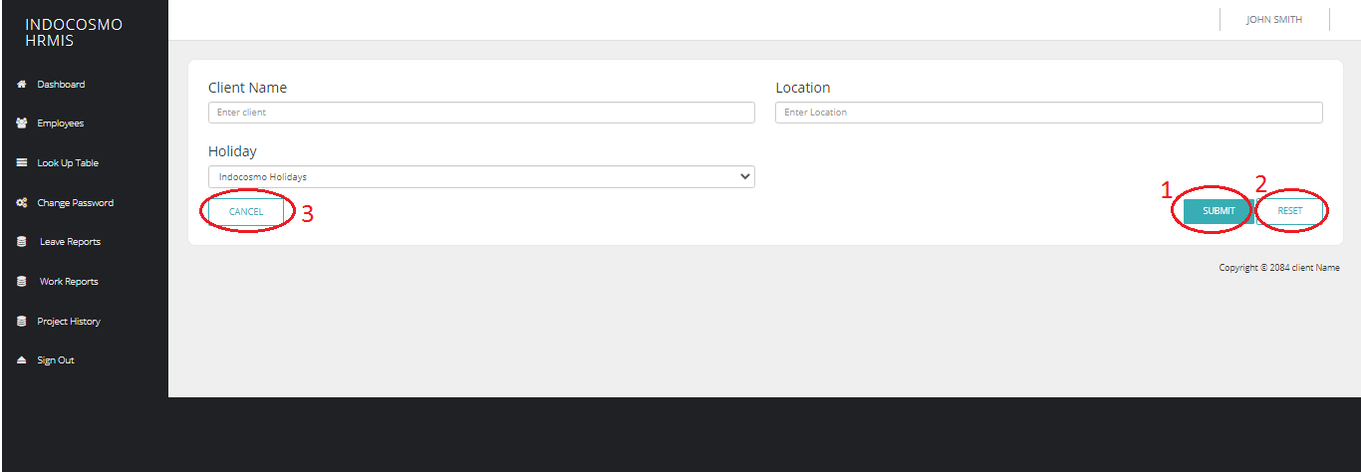
- Submit : On submit, new client will be created and page will be redirected to view clients page(1.2.3.1).
- Reset : On reset, details entered will be reseted.
- Cancel : On cancel, creation of client will be discarded and redirecetd to view clients page(1.2.3.1).

Edit Client
Client will be edited in this page includes creation of projects and project manager for employee project forms.
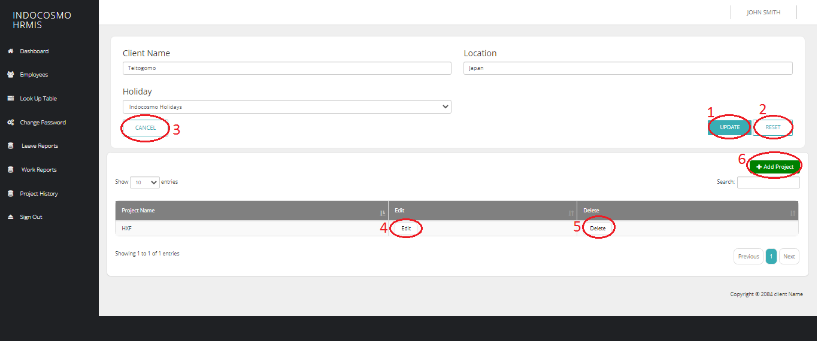
- Submit : On submit, client will be edited and page will be redirected to view client page(1.2.3.1).
- Reset : On reset, details entered will be reseted.
- Cancel : On cancel, editing of client will be discarded and redirecetd to view client page(1.2.3.1).
- Edit : Page will be redirected to the editing page of the correspond project.
- Delete : Corresponding project will be deleted.
- Add Project : Page will be redirected to project creation page.

Add Project
This page allows administrator to create projects for clients.
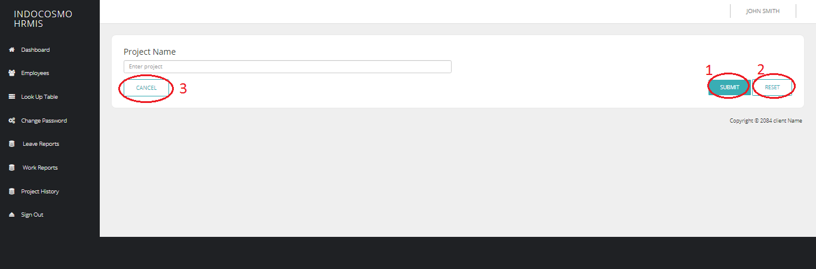
- Submit : On submit, the project will be created and redirected to edit client page(1.2.3.3).
- Reset : On click, enetered details will be reset.
- Cancel : On cancel, enetered details will be discarded and redirected to edit client page(1.2.3.3).

Edit Project
On this page project details will be edited including project manager for corresponding project will be created,edited and deleted.
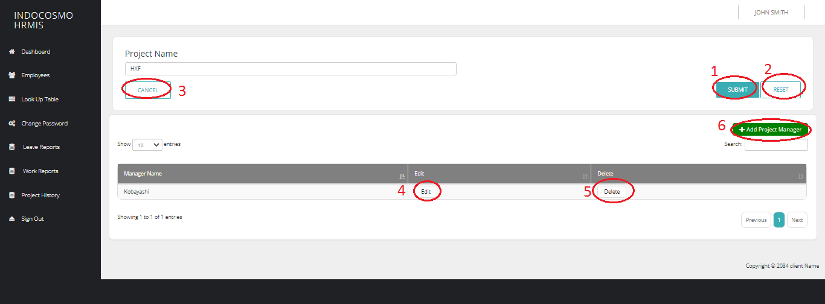
- Submit : On submit, project will be edited and page will be redirected to edit client page(1.2.3.3).
- Reset : On reset, details entered will be reseted.
- Cancel : On cancel, editing of project will be discarded and redirecetd to edit client page(1.2.3.3).
- Edit : Page will be redirected to the editing page of the correspond project manager.
- Delete : Corresponding project manager will be deleted.
- Add Project Manager : Page will be redirected to project manager creation page.

Add Project Manager
This page allows administrator to create project manager for clients.

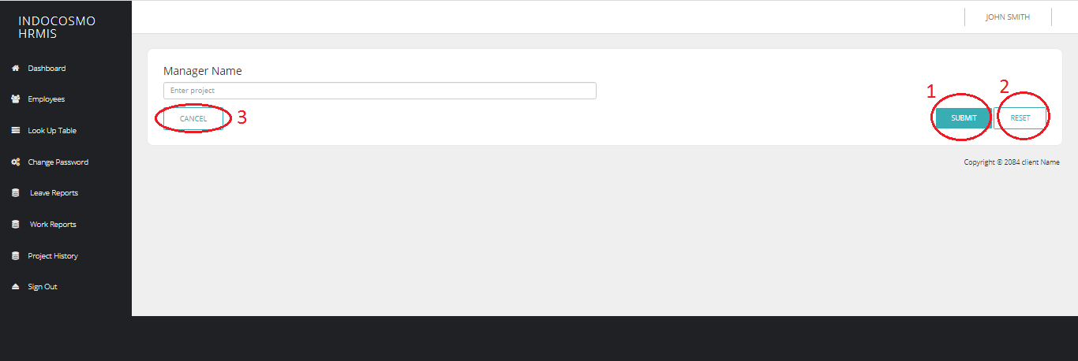
- Submit : On submit, new project manager will be created and page will be redirected to edit project page(1.2.3.3.2).
- Reset : On reset, details entered will be reseted.
- Cancel : On cancel, creation of project manager will be discarded and redirecetd to edit project page(1.2.3.3.2).

